**Project # 2 - Hospital**

**Minsun Kim**

**CS 331**

ER Diagram ----

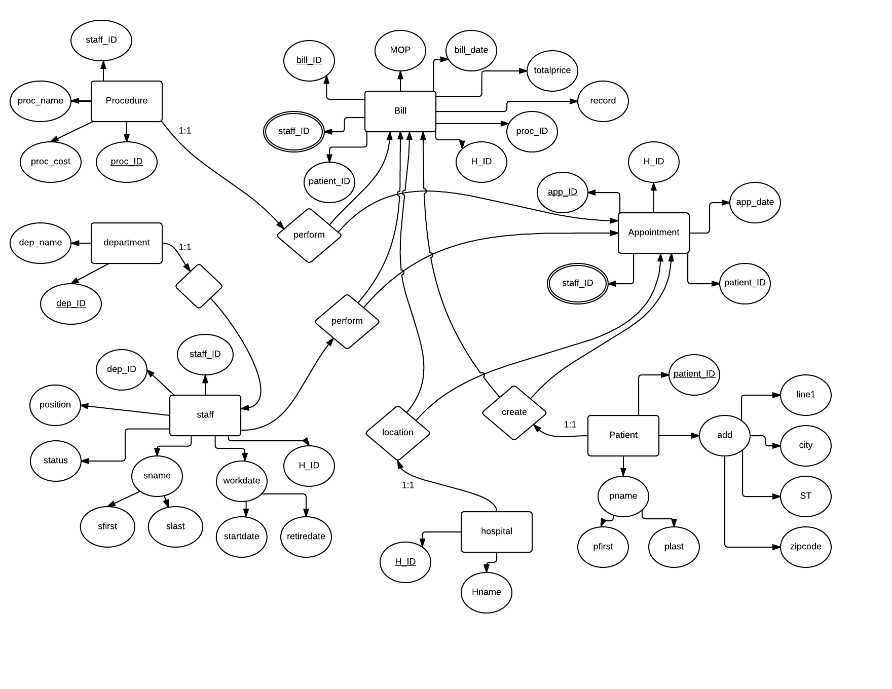

Staff (staffID, sfirst, slast, position, depID, H_ID, startdate, retiredate)

Patient (patient_ID, pfirst, plast,line1, city, state, zipcode)

Department (depID, depname)

Hospital (H_ID, hname)

Procedure (procID, procname, price, staffID)

Appointment (appID, appdate, patient_ID, H_ID, staffID)

Bill (billID, billdate, totalprice, procID, patient_ID, staffID, H_ID, mathodofpayment, record)

Black line – primary key / red line – foreign key

Tables

1. Staff

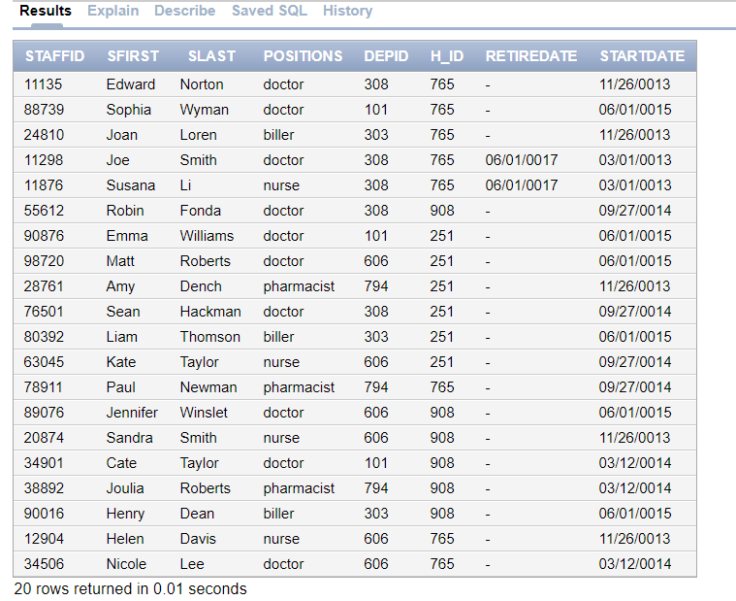

1. Patient

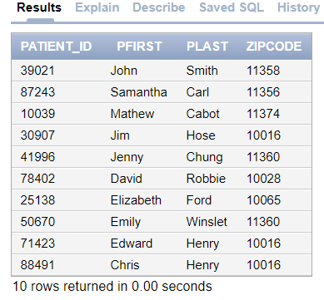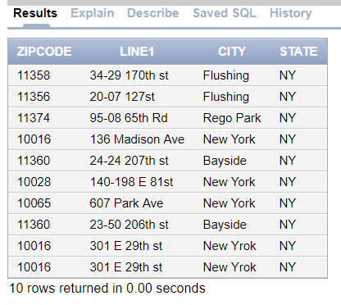

1. Department

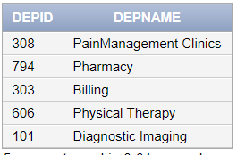

1. Hospital

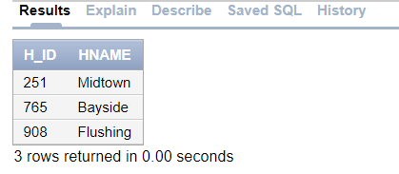

1. Procedure

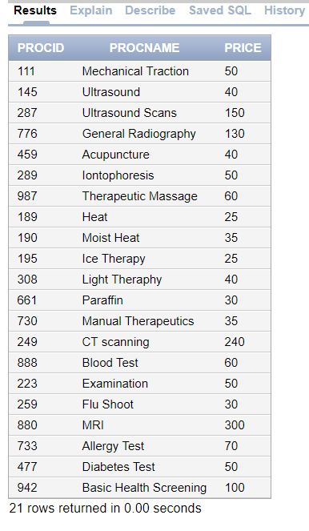

1. Appointment

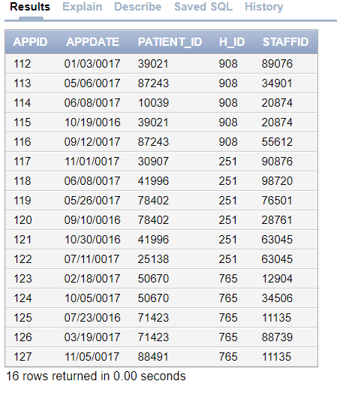

1. Bill

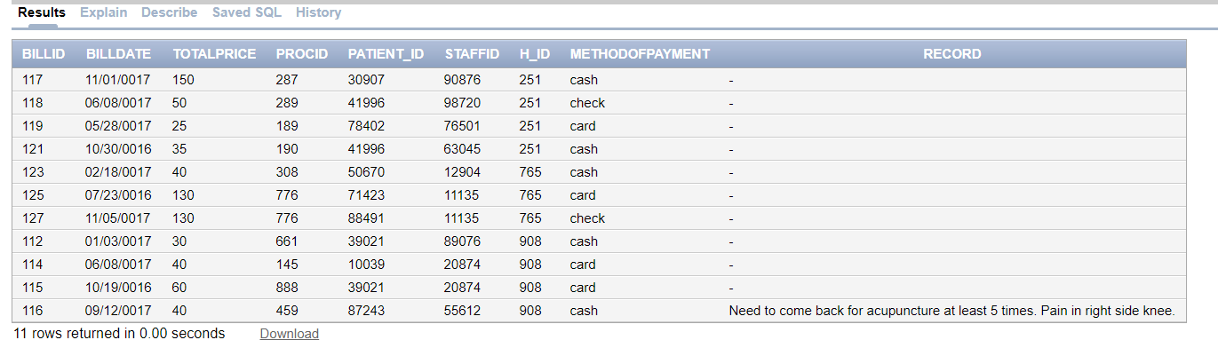

For all questions, standard date of today is 11/14/2017

Q1)

Identify the number procedures performed by each hospital location during last 6 months. Display the hospital name and number of procedures. Display one row for each hospital. Use a function to answer this question.

Answer 🡪

select hospital.Hname, count (bill.procID) AS NumberOfProcedures From bill

left Join hospital On bill.H_ID = hospital.H_ID

where bill.billdate > '05/14/17'

Group By hname;

Result 🡪

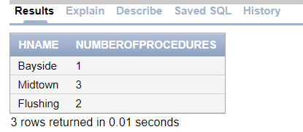

Q2)

Identify the number procedure performed by each hospital department during last 6 months. Display the hospital, department name and number of procedures. Display one row for each hospital and department. Use a function to answer this question.

Answer 🡪

select hospital.hname, department.depname,count (bill.procID) AS NumberOfProcedures From bill

left join hospital on hospital.H_ID = bill.H_ID

left join staff on staff.staffID = bill.staffID

left join department on department.depID = staff.depID

where bill.billdate > '05/14/17'

Group by hname, depname

order by hname asc;

Result 🡪

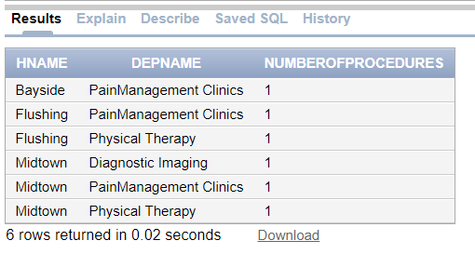

Q3)

Identify 09/12/2017’s acupuncture procedure result for patient Samantha Carl. Display the patient name, procedure and results of the procedure.

Answer 🡪

select patient.pfirst, patient.plast, procedure.procname, bill.record from bill

left join patient on patient.patient_ID = bill.patient_ID

join procedure on procedure.procID = bill.procID

where patient.pfirst = 'Samantha' and patient.plast = 'Carl' and bill.billdate = '09/12/17';

Result 🡪

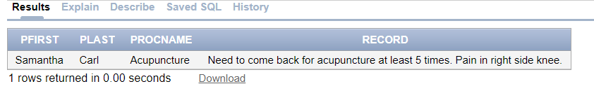

Q4)

Identify the number of procedures and revenue at Flushing hospital during last one year. Display one row identifying the number of procedures and revenue. Use a function to answer this question.

Answer 🡪

select sum (bill.totalprice) AS revenue, count (bill.procID) AS NumberOfProcedure from bill

join hospital on hospital.H_ID = bill.H_ID

where hospital.hname = 'Flushing' and bill.billdate > '11/14/16';

Result 🡪

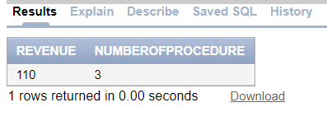

Q5)

Identify all patients seen last two years who received general radiography. Display the patient name, date of service and doctor who prescribed the procedure.

Answer 🡪

select patient.pfirst, patient.plast, bill.billdate, staff.sfirst, staff.slast from bill

left join staff on staff.staffID = bill.staffID

left join patient on patient.patient_ID = bill.patient_ID

join procedure on procedure.procID = bill.procID

where procedure.procname = 'General Radiography' and bill.billdate > '11/14/15';

Result 🡪

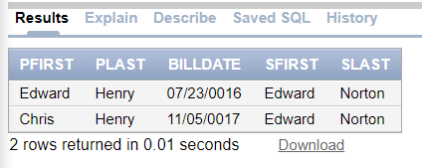

Q6)

Dr.Smith and Nurse Li retired on June 1, 2017 and are no longer employed by the hospital. Identify the SQL to implement.

Answer 🡪

update staff

set retiredate = '06/01/17'

where slast = 'Smith' and positions = 'doctor' or slast = 'Li' and positions = 'nurse';

and then..

select sfirst, slast, retiredate from staff

where slast = 'Smith' and positions = 'doctor' or slast = 'Li' and positions = 'nurse';

Result 🡪  
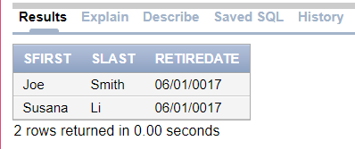

Q7)

Identify the patients who have not received general radiography during last two years. Display the patient name. Use a nested select to answer this question.

Answer 🡪

select distinct patient.pfirst, patient.plast from patient

join bill on bill.patient_ID = patient.patient_ID

join procedure on procedure.procID = bill.procID

where not procname = 'General Radiography' AND bill.billdate > '11/14/15';

Result 🡪

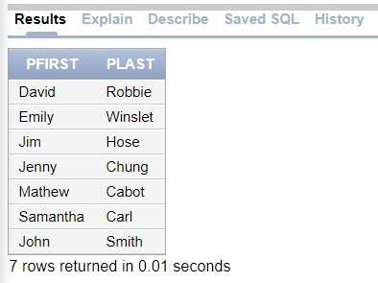

Q8)

Identify the patients who have not visited the hospital in the last one year. Display the patient name.

Answer 🡪

select patient.pfirst, patient.plast from patient

left join bill on bill.patient_ID = patient.patient_ID AND bill.billdate > '11/14/16'

where bill.patient_ID is null;

Result 🡪

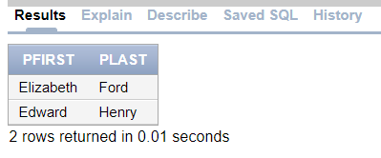

Q9)

Increase the price of all paraffin by 20%. Display the price before and after the change.

Answer 🡪

update procedure

set price = price * 1.2

where procname = 'Paraffin';

Result 🡪

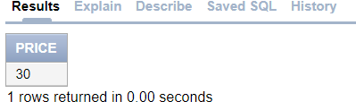 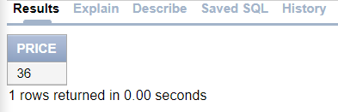

Q10)

Identify the top 10 procedures performed at the Flushing hospital in the last 2 years. Display the procedure name and number of procedures. Display one row for each procedure. Display the procedure with the most activity first.

Answer 🡪

select procedure.procname, count (bill.procID) AS NumberOfProcedure from bill

left join procedure on procedure.procID = bill.procID

left join hospital on hospital.H_ID = bill.H_ID

where bill.billdate > '11/14/15' AND hospital.hname = 'Flushing' and rownum <=10

group by procname

order by NumberOfProcedure asc;

Result 🡪

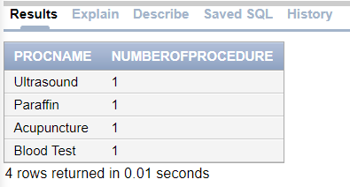

Q11)

A new patient visits the hospital for blood test. Identify the SQL to implement.

***new patient name : Merlin Winslet , patient num : 76548, zipcode: 11362

*** bill for blood test.

Answer 🡪

insert into patient (patient_ID, pfirst, plast, zipcode)

values (76548, 'Merlin', 'Winslet', 11362);

insert into bill(billID, billdate, totalprice, procID, patient_ID, staffID, H_ID, methodofpayment)

values (128, '11/14/17', 60, 888, 76548, 12904, 765, 'cash');

select * from patient

join bill on bill.patient_ID = patient.patient_ID

where patient.patient_ID = 76548;

Result 🡪

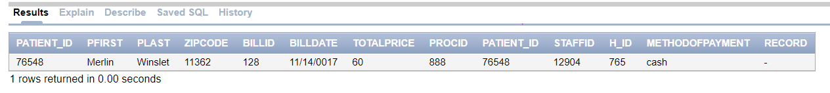

Q12)

Display the table structure using the SQL Describe operation.

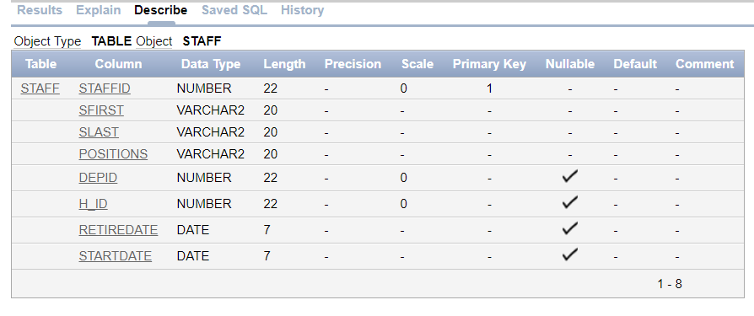

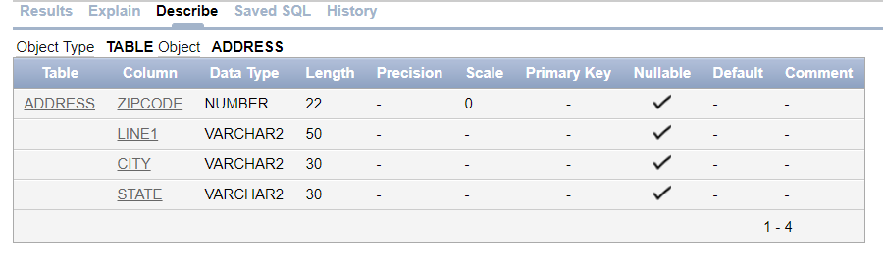 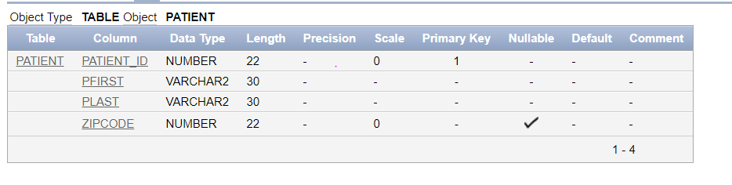 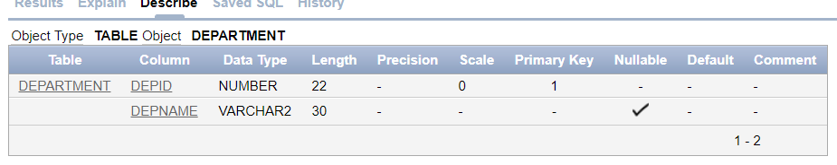 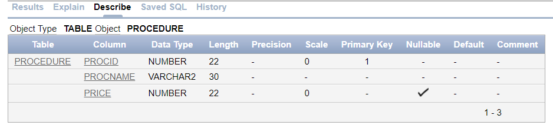

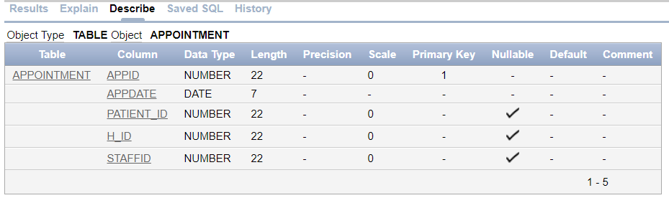 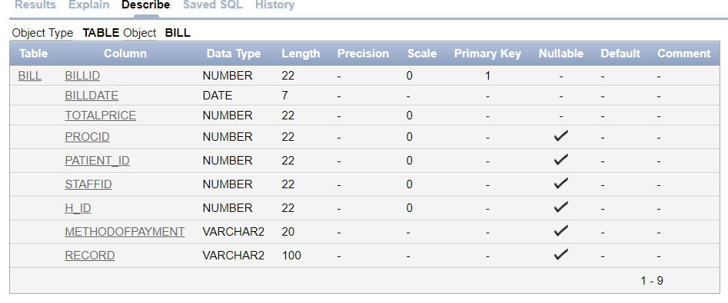 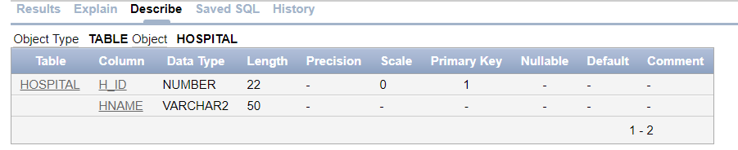

Q13)

Display the Oracle version by entering select * from product_component_version;

